**Indirect Shame, Direct Impact: How Others' Body Talk Shapes Why We Work Out**

Lily Gates

Survey Methodology Department, University of Maryland

SURV 400: Fundamentals of Survey and Data Science

Dr. Coutts

May, 18, 2025

**Indirect Shame, Direct Impact: How Others' Body Talk Shapes Why We Work Out**

In today’s appearance-focused culture, the messages individuals hear about bodies—whether directed at them or overheard—can subtly shape their thoughts, self-perceptions, and behaviors. While much research has investigated the direct experiences of body-shaming and their effects on physical and psychological well-being, less attention has been given to indirect exposure. These self-directed body-shaming comments—that is, self-deprecating remarks made by others about their own bodies—can be overheard by those nearby or observed through a screen. Although these comments are not aimed at the listener, they may influence how individuals perceive their own bodies and the motivations that underlie their exercise behavior.

The present study examines how exposure to overheard self-deprecating body comments affects exercise motivation, with a focus on whether the motivation is intrinsic (driven by internal satisfaction, such as enjoyment or health) or extrinsic (driven by external rewards or pressures, such as appearance or social approval). The study also explores whether self-esteem moderates this relationship, given its central role in how individuals process social information about body image.

Intrinsic motivation refers to engaging in an activity for its inherent enjoyment or personal value (Ryan & Deci, 2000). In contrast, extrinsic motivation is driven by external factors, such as appearance-related goals or social expectations (Deci & Ryan, 1985). Prior research has shown that individuals exposed to body-related pressures often experience a shift toward extrinsic motivation, which has been associated with less sustainable and less psychologically healthy exercise patterns (Ingledew & Markland, 2008).

Body-shaming, typically studied as a form of direct social feedback, is associated with negative body image, disordered eating, and an increased likelihood of exercising for appearance-related reasons (Holland & Tiggemann, 2016). However, self-directed body-shaming, such as someone saying “I feel gross after eating that” or “I need to lose 10 pounds,” may also function as a social comparison cue. Exposure to these statements may prompt listeners to reflect on their own appearance or habits, even if unintentionally.

This study posits that greater exposure to overheard self-deprecating body comments will be associated with higher extrinsic motivation and possibly lower intrinsic motivation to exercise. It is hypothesized that individuals with lower self-esteem will be more vulnerable to these effects, given prior findings that low self-esteem heightens sensitivity to social comparison and negative body image messages (Vartanian & Dey, 2013). Conversely, individuals with higher self-esteem may be more resilient, maintaining intrinsic reasons for exercising despite exposure to negative body talk.

In sum, the present research seeks to understand how ambient social influences—namely, overheard self-directed body-shaming—may affect young adults’ reasons for exercising, and whether self-esteem serves as a buffer or amplifier in these dynamics. The findings may contribute to a broader understanding of the social-psychological mechanisms that influence health behaviors in subtle but meaningful ways.

**Methods**

**Participants**

The target population for this study consisted of young adults residing in the Washington, D.C. metropolitan area. Participants were recruited via convenience sampling methods. The survey link was disseminated through direct messages and group communications within the University of Maryland academic community, specifically targeting students enrolled in courses such as Break Through Tech UMD, BSOS 326, INST 414, INST 462, PSYC 341, and SURV 400 during the Spring 2025 semester. Recruitment occurred primarily through the University of Maryland’s Enterprise Learning Management System (ELMS: Canvas) and associated GroupMe chats. Additional participants were recruited through text messages sent to friends and family members, along with a brief explanation that participation would support an academic research final project. Participation was self-selected.

A total of 75 individuals responded to the survey, with 70 responses retained after excluding five participants who left multiple non-demographic questions unanswered. Although survey items were optional, cases with substantial missing data on primary variables were removed to maintain data quality and ensure the validity of item-level analyses.

The final sample (*n* = 62) consisted predominantly of young adults aged 18 to 25, with smaller representations in the 26–30, 31–40, and 41–60 age ranges. The mean age was 22.4 years (*SD* = 7.16), ranging from 18 to 57 years. Regarding gender identity, 66.1% identified as women, 22.6% as men, 9.7% as non-binary, and 1.6% preferred not to disclose. When reported by biological sex, 75.8% were female, 22.6% male, and 1.6% preferred not to say. Racial/ethnic identification included Asian/Pacific Islander (33.9%), White/Caucasian (27.4%), Black/African American (21.0%), Hispanic or Latino (3.2%), Other (1.6%), with 11.3% missing race data and 1.6% preferring not to disclose.

**Measures**

### *Overheard Self-Deprecating Comments About Body Image as a Predictor Variable*

The predictor variable in this study was a self-developed scale designed to measure exposure to overheard self-deprecating comments related to body image. This latent construct was hypothesized to be positively associated with extrinsic motivation and negatively associated with intrinsic motivation to exercise. Participants were presented with a series of statements reflecting common self-critical remarks people make about their own bodies or habits. These items were organized thematically (e.g., body image, exercise, diet) and phrased to capture indirect social influence—that is, comments overheard rather than directly addressed to the participant. Exposure to these comments was assessed using an 8-item scale (see Appendix B), where participants reported the frequency with which they had heard others make self-critical remarks related to body image, weight, diet, and exercise (e.g., “I wish I could be more confident in my body”). Responses were recorded on a 6-point Likert scale ranging from 0 (Never hear this) to 5 (Very frequently hear this), with higher scores indicating greater exposure.

The self-directed body-shaming scale demonstrated good internal consistency, with a Cronbach’s alpha of *α* = 0.87. Dropping any item did not improve *α*, indicating that all items contribute meaningfully to the scale’s reliability. The Omega Total coefficient was 0.92, indicating excellent overall reliability and supporting the use of the total score as a highly reliable measure of exposure to self-directed body shaming. The Omega Hierarchical coefficient of 0.71 suggests that the scale is largely unidimensional, with a general factor explaining a substantial amount of variance, although some multidimensionality remains.

***Self-Esteem as a Moderating Variable***

Self-esteem was measured as a latent construct using a 7-item abridged version of the Rosenberg Self-Esteem Scale (RSES; Rosenberg, 1965), which assesses general feelings of self-worth and self-acceptance. Participants rated their agreement with each statement using a 6-point Likert-type scale ranging from 0 (*Not at all true for me*) to 5 (*Extremely true for me*). The scale included both positively and negatively worded items, such as “I feel that I have a number of good qualities” and “I feel I do not have much to be proud of” (reverse-scored).

A total score was computed by averaging across all seven items after reverse-scoring the negatively worded statements. Higher scores indicated greater self-esteem. The scale demonstrated strong internal consistency, with a Cronbach’s alpha of *α* = .87. Item-level analysis revealed that removing item RSE_Q7 would slightly increase *α* to .88, suggesting it was the least internally consistent item. However, the item was retained to preserve content coverage. The scale also demonstrated excellent reliability, with an Omega Total of .92, supporting the use of the total score. An Omega Hierarchical of .81 indicated that most of the variance was accounted for by a single general factor, confirming the scale’s unidimensional structure.

***Motivation to Exercise as an Outcome Variable***

Motivation to exercise was assessed using a 12-item adapted version of the Exercise Motivation Inventory-2 (EMI-2; Markland, 2007; see Appendix C). The selected items reflected both intrinsic (e.g., emotional well-being, physical health, self-improvement, social connection) and extrinsic (e.g., appearance concerns, social pressure, competitive performance) motivations. Participants rated each item on a 6-point Likert-type scale ranging from 0 (*Not at all true for me*) to 5 (*Extremely true for me*), with higher scores indicating stronger agreement with each motivation. Prior validation of the full EMI-2 supports its use in college populations (Kim & Cho, 2022).

The intrinsic motivation subscale demonstrated good internal consistency, with a Cronbach’s alpha of *α* = .85. Removal of any item decreased reliability, indicating that all items contributed positively to the scale’s consistency. The Omega Total coefficient was .91, indicating excellent overall reliability and supporting the use of the total score as a reliable measure of intrinsic motivation. The Omega Hierarchical value of .67 suggests that, while a general intrinsic motivation factor accounted for a substantial proportion of variance, some multidimensionality remains—likely reflecting sub-factors within the scale.

The extrinsic motivation subscale showed acceptable internal consistency, with a Cronbach’s alpha of *α* = .72. Notably, if item E_PA_Q3 were removed, *α* would increase to .79, indicating this item may be the weakest contributor to the scale’s reliability. The Omega Total coefficient was .82, indicating good overall reliability and supporting use of the total score as a measure of extrinsic motivation. The Omega Hierarchical value of .69 indicates that a moderate amount of variance was explained by a general factor, suggesting some multidimensionality but sufficient unidimensionality to justify the composite score.

### *Sex Assigned at Birth as a Control Variable*

Sex assigned at birth was included as a control variable in the interaction analyses to account for potential differences in exercise motivation and exposure to self-deprecating comments that may be influenced by biological sex. Participants self-reported their sex assigned at birth by selecting from the options: *Male*, *Female*, *Intersex*, or *Prefer not to say*. For analysis purposes, this variable was treated categorically and included as a covariate to reduce potential confounding effects on the relationships among the predictor, moderator, and outcome variables. The sample was predominantly female (*n* = 47, 75.8%), with males comprising 22.6% (*n* = 14), and 1.6% (*n* = 1) preferring not to disclose their sex assigned at birth.

**Procedure**

Participants were recruited using convenience sampling methods. The researcher distributed a link to the online questionnaire via ELMS (Canvas) announcements, GroupMe messages, and personal text messages sent to peers and classmates. The survey was hosted on Qualtrics.

Upon accessing the survey, participants were presented with an informed consent form and asked to indicate their agreement to participate. The survey was intentionally ordered to minimize priming effects and reduce potential emotional influence. First, participants completed a 7-item self-esteem measure, followed by 12 items assessing motivation to exercise (the outcome variable). The 8-item scale assessing exposure to overheard self-deprecating comments about body image (the predictor variable) was presented afterward to avoid negatively priming respondents before answering the motivation items. Demographic questions were positioned at the end of the survey to minimize the risk of stereotype threat influencing earlier responses.

The survey took approximately 3–5 minutes to complete. Upon submission, participants were shown a closing message thanking them for their participation and providing the researcher’s email address in case they had questions or wished to withdraw their data from the study. No formal debriefing was included.

**Data Analysis**

***Preprocessing Data***

All analyses were conducted using R (version 4.5.0). The primary scales used in this study—the adapted Rosenberg Self-Esteem Scale (RSE_data), Intrinsic Motivation for Exercise (intrinsic_motiv_data), Extrinsic Motivation for Exercise (extrinsic_motiv_data), and Self-Directed Body Shaming (bodyshame_data)—demonstrated high internal consistency, with Omega Total values exceeding 0.80. Based on this, total scores for each scale were computed by summing the respective item responses. Before scoring, all items were checked for correct coding. Reverse coding was applied to RSE items 2, 4, and 6 (see Appendix A) to ensure consistent directionality across all items. Total scores were computed using the rowSums() function with na.rm = TRUE to accommodate missing data. Because the scales differed in the number of items, all total scores were standardized (i.e., converted to z-scores with mean = 0 and standard deviation = 1) to allow for comparability across variables. These standardized scores were saved in new variables for use in subsequent analyses.

***Testing Assumptions for Modeling***

Prior to conducting regression analyses, key linear model assumptions were evaluated. Heteroscedasticity was assessed using both visual inspection of residuals versus fitted value plots and the Breusch-Pagan Non-Constant Variance test via the ncvTest() function from the car package.

Separate linear models were fitted predicting standardized extrinsic and intrinsic motivation scores from standardized self-directed body-shaming scores (Figure F1, Appendix F). Results indicated heteroscedasticity in the model predicting extrinsic motivation (*p* = .043), suggesting that the variance of residuals varied across levels of the predictor. This violates the assumption of homoscedasticity, which can result in inefficient estimates and biased standard errors, thereby affecting the validity of hypothesis tests and confidence intervals. Visual inspection supported this finding, with a funnel-shaped spread observed in the residuals plot.

In contrast, no evidence of heteroscedasticity was found in the model predicting intrinsic motivation (*p* = .54), indicating that the assumption of constant variance was reasonably met for that model.

Normality of key variables was confirmed using Shapiro-Wilk tests (Figure F2, Appendix F). Q-Q plots and histograms of the standardized scores for intrinsic motivation, extrinsic motivation, body shame, and self-esteem revealed relatively normal distributions. Residuals from the regression models also showed approximate normality, with only minor deviations at the tails (Figure F3, Appendix F). Histograms appeared roughly bell-shaped and symmetric across variables (Figure F4, Appendix F).

To assess the linearity assumption, scatterplots were created with fitted regression lines and 95% confidence intervals for each predictor-outcome pair. These plots suggested weak or unclear linear relationships, particularly between body shame/self-esteem and motivation outcomes, indicating potential violations of linearity (Figure F5, Appendix F).

Overall, the data met the assumptions of normality and, for intrinsic motivation, homoscedasticity. However, the evidence of heteroscedasticity in the extrinsic motivation model and the weak linear relationships across variables suggest that linear models may underfit the data and overlook complex associations. To address these limitations, alternative methods such as heteroscedasticity-consistent standard errors (e.g., White’s robust SEs) or weighted least squares regression are recommended. Additionally, when modeling moderation effects involving self-esteem, consideration should be given to non-linear relationships and variance heterogeneity, both of which may impact the accuracy and interpretation of interaction effects.

***Correlation Using Pearson’s r and Spearman’s rho***

Pearson’s correlation coefficients were computed to assess linear relationships among the standardized variables: exposure to overheard negative body talk (*bodyshame_total_z*), intrinsic motivation, extrinsic motivation, and self-esteem (*RSE_total_z*). Pearson’s *r* assumes linearity and approximate normality of the data, conditions that were largely supported based on diagnostic plots and Shapiro-Wilk test results.

To account for potential deviations from normality and detect monotonic but non-linear relationships, Spearman’s rank-order correlation coefficients (ρ) were also calculated. Spearman’s method is non-parametric and more robust to outliers and skewed distributions, offering a complementary perspective to Pearson’s *r*.

Using both correlation methods allowed for a comprehensive assessment of associations among key psychological constructs, ensuring the robustness of conclusions even in the presence of slight non-normality or non-linearity (see Figure F5, Appendix F).

***Regression Analysis: Linear and Loess Models***

To explore the predictive relationships between body shame and types of exercise motivation, both linear and loess regressions were applied. The linear regression model estimated a constant rate of change in intrinsic and extrinsic motivation as a function of *bodyshame_total_z*, providing an interpretable effect size under the assumption of linearity.

In parallel, loess (locally estimated scatterplot smoothing) regression was conducted to flexibly model potential non-linear patterns. As a non-parametric approach, loess fits localized subsets of the data, making it especially useful when visual inspection suggests curvature or non-uniform trends. This approach was particularly warranted given earlier evidence from scatterplots and Q-Q plots that hinted at mild departures from linearity.

The comparison of linear and loess trends (see Figure F6, Appendix F) allows for a nuanced understanding of how exercise motivation might vary across different levels of internalized body shame, including potential threshold effects or plateaus not captured by a linear model.

### *Moderation Analysis: Role of Self-Esteem*

A moderation analysis was conducted to test whether self-esteem (*RSE_total_z*) moderates the relationship between exposure to body shame and exercise motivation. The central hypothesis was that individuals with higher self-esteem may be less vulnerable to the negative motivational impacts of overheard body-shaming comments, serving as a psychological buffer.

Interaction terms were included in the regression models to formally assess moderation, with body shame (*bodyshame_total_z*), self-esteem (*RSE_total_z*), and their interaction as predictors of both intrinsic and extrinsic motivation outcomes. Visualization of the interaction effects (Figure F7, Appendix F) facilitated interpretation by illustrating how the strength and direction of the body shame–motivation relationship varied across self-esteem levels.

This analysis provides insight into individual differences in resilience to social body image pressures and supports the theoretical importance of self-esteem as a protective factor in motivation-related processes.

**Results**

### Correlation Analysis

Pearson’s correlation coefficients were calculated to assess linear relationships among exposure to overheard negative body talk (*bodyshame_total_z*), intrinsic motivation (*intrinsic_motiv_total_z*), extrinsic motivation (*extrinsic_motiv_total_z*), and self-esteem (*RSE_total_z*). Due to slight skewness in some variables and the potential for non-linear relationships, Spearman’s rank-order correlations (ρ) were also computed as a non-parametric alternative to detect monotonic associations.

Exposure to overheard negative body talk was moderately positively correlated with extrinsic motivation to exercise, *r* = .37, suggesting that greater exposure is associated with higher extrinsic motivation. This relationship was consistent with Spearman’s ρ = .41.

Exposure was also moderately negatively correlated with self-esteem, *r* = –.31 and ρ = –.29, indicating that increased exposure to negative body talk is associated with lower self-esteem.

In contrast, no significant relationship was found between exposure and intrinsic motivation (*r* = –.003; ρ = .008), suggesting no meaningful linear or monotonic association.

Intrinsic motivation and extrinsic motivation were moderately positively correlated (*r* = .44; ρ = .40), indicating that individuals with high intrinsic motivation also tended to report higher extrinsic motivation. Intrinsic motivation showed weak, non-significant positive correlations with self-esteem (*r* = .17; ρ = .16).

Self-esteem was slightly negatively correlated with extrinsic motivation (*r* = –.13; ρ = –.09), though neither correlation reached statistical significance.

Overall, these findings suggest that exposure to overheard negative body talk is associated with higher extrinsic motivation and lower self-esteem, while intrinsic motivation appears largely unrelated to both exposure and self-esteem. The consistency between Pearson and Spearman coefficients supports the robustness of these results, even in the presence of minor deviations from normality.

**Linear Regression and Loess Regression for Predictor and Outcome Variables**

A linear regression was conducted to examine whether body shame (*bodyshame_total_z*) predicts extrinsic motivation to exercise (*extrinsic_motiv_total_z*). The model was statistically significant, β = 0.37, *p* = .003, with body shame accounting for approximately 14% of the variance in extrinsic motivation (*R²* ≈ .14). This indicates that individuals reporting higher levels of body shame also tend to exhibit greater extrinsic motivation, suggesting that external factors such as appearance or social approval may become more salient as body shame increases.

In contrast, the linear regression model predicting intrinsic motivation (*intrinsic_motiv_total_z*) from body shame was not significant, β = −0.003, *p* = .983, with *R²* near zero. Residuals from this model appeared normally distributed, suggesting the assumptions of linear regression were met. However, the lack of a statistically significant relationship indicates that intrinsic motivation does not vary systematically with body shame.

To explore potential non-linear relationships, loess regression was also applied. Loess (locally estimated scatterplot smoothing) fits a flexible, non-parametric curve to the data, allowing for detection of complex, non-linear patterns without assuming a fixed functional form. The loess model for extrinsic motivation had an effective degrees of freedom of approximately five, indicating a moderately flexible fit—capable of reflecting nuanced patterns in the data while avoiding overfitting.

The residual standard error (RSE) of approximately 0.87 suggests that, while body shame contributes meaningfully to predicting extrinsic motivation, a substantial amount of variation remains unexplained. This underscores the likelihood that other psychological, social, or contextual factors also influence extrinsic exercise motivation.

Visually, the shape of the loess curve suggests that extrinsic motivation may increase with body shame up to a certain threshold, then plateau or shift trajectory. This non-linearity highlights the complexity of motivational dynamics, particularly how social-emotional factors like shame interact with behavioral outcomes.

Overall, these analyses indicate that body shame is a significant, though partial, predictor of extrinsic motivation. In contrast, intrinsic motivation appears unaffected by levels of body shame, reinforcing the notion that internal and external drivers of exercise behavior are shaped by distinct psychological processes.

**Evaluating the Moderation of Self-Esteem**

#### *Extrinsic Motivation Model*

A multiple regression analysis was conducted to assess whether self-esteem moderates the relationship between overhearing body shame and extrinsic motivation to exercise. The overall model was statistically significant, *F*(3, 58) = 3.06, *p* = .035, accounting for approximately 14% of the variance in extrinsic motivation (*adjusted R²* = .092).

Overhearing body shame emerged as a significant predictor of extrinsic motivation, *b* = 0.36, *t*(58) = 2.78, *p* = .007, 95% CI [0.10, 0.62], indicating that higher levels of negative body talk were associated with stronger external exercise motives, such as striving for appearance or avoiding social judgment.

In contrast, self-esteem was not a significant predictor, *b* = –0.02, *t*(58) = –0.13, *p* = .90, 95% CI [–0.27, 0.24], and the interaction between overhearing body shame and self-esteem was also non-significant, *b* = –0.02, *t*(58) = –0.13, *p* = .90, 95% CI [–0.27, 0.24]. These results suggest that self-esteem does not moderate the relationship between overhearing body shame and extrinsic motivation—meaning the strength of the association remains consistent across different levels of self-esteem.

#### *Intrinsic Motivation Model*

A parallel model was tested for intrinsic motivation. The overall regression was not statistically significant, *F*(3, 58) = 0.64, *p* = .59, and explained negligible variance (*adjusted R²* = –0.02).

None of the predictors in the model reached significance. Body shame (*b* = 0.05, *t*(58) = 0.38, *p* = .71, 95% CI [–0.22, 0.32]), self-esteem (*b* = 0.19, *t*(58) = 1.38, *p* = .17, 95% CI [–0.06, 0.44]), and their interaction (*b* = –0.01, *t*(58) = –0.10, *p* = .92, 95% CI [–0.28, 0.25]) did not significantly predict intrinsic motivation.

These findings suggest that self-esteem does not significantly moderate the effects of body shame on either extrinsic or intrinsic motivation to exercise. While body shame is a meaningful predictor of extrinsic motivation, its influence appears stable across levels of self-esteem. Intrinsic motivation, by contrast, remains largely unaffected by both body shame and self-esteem in this model.

**Discussion**

### Summary of Findings

Pearson and Spearman correlation coefficients were calculated to explore associations between exposure to overheard negative body talk, types of exercise motivation, and self-esteem. Results showed that exposure to negative body talk was moderately positively correlated with extrinsic motivation (*r* = .37, ρ = .41, *p* < .05) and negatively correlated with self-esteem (*r* = –.31, ρ = –.29, *p* < .05). No significant correlations emerged between exposure and intrinsic motivation. Intrinsic and extrinsic motivation were moderately positively correlated (*r* = .44, ρ = .40), indicating that individuals may experience both types of motivation simultaneously.

The positive relationship between exposure to negative body talk and extrinsic motivation suggests that overhearing self-deprecating comments about body image may heighten individuals’ focus on external reasons for exercising, such as improving appearance or avoiding social judgment. Conversely, intrinsic motivation appeared unaffected, implying that internal motives like enjoyment or well-being may be more stable in the face of negative social influences.

Consistent with these patterns, linear regression analyses showed that body shame significantly predicted extrinsic motivation (*β* = 0.37, *p* = .003), accounting for about 14% of the variance. This supports the idea that exposure to body shame may amplify motivations rooted in social pressure or appearance concerns. However, body shame did not predict intrinsic motivation (*β* = –0.003, *p* = .983), reinforcing the notion that internal motivators for exercise are less impacted by these external cues.

The residuals in both regression models were normally distributed, supporting the validity of the findings. These results underscore a selective effect of body shame, where it seems to influence extrinsic but not intrinsic exercise motivation.

### Limitations

Several limitations should be acknowledged. First, the survey instrument included fewer items than ideal, which may have limited the granularity and reliability of some measures. Additionally, participants were not given the option to report mental or physical disabilities, which could be relevant to how individuals experience and interpret exercise motivations. Future research should be more inclusive in its demographic and identity-related variables to capture a fuller spectrum of experiences.

### Future Directions

Future studies could benefit from expanding the item pool for both body shame and motivation measures to improve reliability and detect more nuanced effects, including intersectional variables, such as disability status, gender identity, and body diversity experiences, to explore how these factors intersect with exposure to negative body talk, testing potential longitudinal effects to determine whether continued exposure to self-deprecating comments has cumulative impacts on motivation, and investigating whether other moderators, such as body image resilience, perceived social support, or internalization of appearance ideals, influence these relationships.

### Implications

These findings contribute to a growing body of literature emphasizing the social origins of extrinsic motivation to exercise, particularly those rooted in appearance-based concerns and social comparison. Interventions aimed at promoting sustainable, health-based exercise behaviors should consider reducing exposure to self-critical body talk and fostering environments that emphasize intrinsic rewards of physical activity. Encouraging body-neutral or body-positive discourse may also help mitigate the internalization of body shame and reduce extrinsically motivated behaviors that can be emotionally taxing or unsustainable.

**References**

Deci, E. L., & Ryan, R. M. (1985). Intrinsic motivation and self-determination in human

behavior. Springer.<https://doi.org/10.1007/978-1-4899-2271-7>

Holland, G., & Tiggemann, M. (2014). A systematic review of the impact of the use of social

networking sites on body image and disordered eating outcomes. *Body Image, 13*, 100–110.

Ingledew, D. K., & Markland, D. (2008). The role of motives in exercise participation.

*Psychology & Health, 23*(7), 807–828.<https://doi.org/10.1080/08870440701405704>

Kim, S.-H., & Cho, D. (2022). Validation of exercise motivations inventory – 2 (EMI-2) scale for

college students. *Journal of American College Health, 70*(1), 114–121.<https://doi.org/10.1080/07448481.2020.1726929>

Markland, D. (2007). The Exercise Motivations Inventory: The EMI-2. Retrieved from

<https://www.livingstrong.org/articles/ExerciseMotivations.pdf>

Ryan, R. M., & Deci, E. L. (2000). Self-determination theory and the facilitation of intrinsic

motivation, social development, and well-being. *American Psychologist, 55*(1), 68–78.<https://doi.org/10.1037/0003-066X.55.1.68>

Rosenberg, M. (1965). Society and the adolescent self-image. Princeton University Press.

Vartanian, L. R., & Dey, S. (2013). Self-esteem and reactions to body-related social comparisons.

*Body Image, 10*(4), 582–587.<https://doi.org/10.1016/j.bodyim.2013.07.004>

**Appendix A**

**Self-Esteem Scale (Abridged Rosenberg Self-Esteem Scale)**

**Instructions**

Please read each statement carefully and indicate how true each statement is for you. Use the scale below to rate how much you agree with each statement.

**Response scale**

0 = Not at all true for me

1 = Slightly true for me

2 = Somewhat true for me

3 = Mostly true for me

4 = Very true for me

5 = Extremely true for me

**Items**

1. I feel that I have a number of good qualities.
2. All in all, I am inclined to feel that I am a failure. *
3. I am able to do things as well as most other people.
4. I feel I do not have much to be proud of. *
5. I take a positive attitude toward myself.
6. On a whole, I am satisfied with myself.
7. I wish I could have more respect for myself. *

*Items marked with an asterisk were reverse scored during analysis.

**Appendix B  
 Self-Deprecating Body-Shaming (Overheard Comments) Scale**

**Instructions** People sometimes overhear self-critical or body-related comments made by friends, family, or others. The following statements are examples of these kinds of comments.

Please indicate how often you have heard people say things like this (even if not directed at you):

**Response scale**

0 = Never hear this  
 1 = Very rarely hear this  
 2 = Rarely hear this  
 3 = Occasionally hear this  
 4 = Frequently hear this  
 5 = Very frequently hear this

**Items**

1. “I wish I looked like so-and-so, but I’ll never have that kind of body.”
2. “I was in much better shape when I was younger.”
3. “I wish I could eat that, but I’m trying to watch my weight.”
4. “I’ll feel better if I lose some weight.”
5. “I wish I had the discipline to work out.”
6. “I’m so out of shape, I feel like it’ll take years to get to where I want to be.”
7. “I’ve tried so many different things, but I just can’t seem to keep the weight off.”
8. “I wish I could be more confident in my body.”

**Appendix C** **Motivation to Exercise Scale (Adapted from EMI-2)**

**Instructions** Please read each statement carefully and indicate how true each statement is for you when it comes to reasons you might exercise.

**Response Scale** 0 = Not at all true for me  
 1 = Slightly true for me  
 2 = Somewhat true for me  
 3 = Mostly true for me  
 4 = Very true for me  
 5 = Extremely true for me

**Items**

1. Because it makes me feel good
2. To recharge my batteries
3. To prevent health problems
4. To give me goals to work towards
5. To become more athletic
6. To spend time with or make new friends
7. To make new friends
8. To improve my appearance
9. To avoid being judged or ostracized
10. To fit in with my peers
11. Because I enjoy physical competition

**Appendix D**

**Item Coding Summary**

**Table D1  
*Predictor Variable: Exposure to Overheard Self-Deprecating Comments About Body Image***

|  |  |  |
| --- | --- | --- |
| **Code** | **Item Text** | **Category** |
| BS_BI_Q1 | “I wish I looked like so_and_so, but I’ll never have that kind of body.” | Body Image and Physical Appearance |
| BS_BI_Q2 | “I was in much better shape when I was younger.” | Body Image and Physical Appearance |
| BS_WL_Q1 | “I wish I could eat that, but I’m trying to watch my weight.” | Diet and Weight Loss |
| BS_WL_Q2 | “I’ll feel better if I lose some weight.” | Diet and Weight Loss |
| BS_EX_Q1 | “I wish I had the discipline to work out.” | Exercise and Physical Activity |
| BS_EX_Q2 | “I’m so out of shape, I feel like it’ll take years to get to where I want to be.” | Exercise and Physical Activity |
| BS_SC_Q1 | “I’ve tried so many different things, but I just can’t seem to keep the weight off.” | Self-Confidence in Actions and Body Image |
| BS_SC_Q2 | “I wish I could be more confident in my body.” | Self-Confidence in Actions and Body Image |

**Table D2**

***Moderator Variable: Self-Esteem (Rosenberg Self-Esteem Scale, abbreviated)***

|  |  |  |
| --- | --- | --- |
| **Code** | **Item Text** | **Note** |
| RSE_Q1 | “I feel that I have a number of good qualities.” | Positive statement |
| RSE_Q2_RS | “All in all, I am inclined to feel that I am a failure.” | Reverse scored item |
| RSE_Q3 | “I am able to do things as well as most other people.” | Positive statement |
| RSE_Q4_RS | “I feel I do not have much to be proud of.” | Reverse scored item |
| RSE_Q5 | “I take a positive attitude toward myself.” | Positive statement |
| RSE_Q6 | “On a whole, I am satisfied with myself.” | Positive statement |
| RSE_Q7_RS | “I wish I could have more respect for myself.” | Reverse scored item |

**Table D3**

***Outcome Variable: Motivation to Exercise (Adapted EMI-2)***

|  |  |  |
| --- | --- | --- |
| **Code** | **Item Text** | **Motivation Type** |
| I_MEW_Q1 | Because it makes me feel good | Intrinsic – Mental/Emotional Wellness |
| I_MEW_Q2 | To recharge my batteries | Intrinsic – Mental/Emotional Wellness |
| I_PH_Q1 | To prevent health problems | Intrinsic – Physical Health |
| I_PA_Q1 | To give me goals to work towards | Intrinsic – Performance/Athleticism |
| I_PA_Q2 | To become more athletic | Intrinsic – Performance/Athleticism |
| I_SC_Q1 | To spend time with or make new friends | Intrinsic – Social Connection |
| I_SC_Q2 | To make new friends | Intrinsic – Social Connection |
| E_AD_Q1 | To improve my appearance | Extrinsic – Appearance-Driven |
| E_SP_Q1 | To avoid being judged or ostracized | Extrinsic – Social Pressure |
| E_SP_Q2 | To fit in with my peers | Extrinsic – Social Pressure |
| E_PA_Q3 | Because I enjoy physical competition | Extrinsic – Performance/Athleticism (Competitive) |

**Appendix E**

**Demographics**

**Instructions** The following questions ask about some basic demographic information. Your responses will remain confidential.

**Age**

Please indicate your age in years.

[Text Entry: _______________]

**Sex Assigned at Birth** What was your biological sex assigned at birth?

* Male
* Female
* Intersex
* Prefer not to say

**Gender Identity**How do you identify your gender?

* Man
* Woman
* Non-binary
* Prefer to self-describe: [Text Entry: _______________]
* Prefer not to say

**Race/Ethnicity** Please select all that apply:

* White
* Black or African American
* Hispanic or Latino
* Middle Eastern or North African
* Asian/Pacific Islander  
  Indigenous American/Alaskan Native
* Native Hawaiian/Pacific Islander
* Other: [Text Entry: _______________]
* Prefer not to say

**Coding Note:** Age was entered as a continuous variable in years. Sex assigned at birth, gender identity, and race/ethnicity were initially coded as numeric values for data processing, then converted back to their original categorical labels for analysis and reporting. Race/ethnicity allowed for multiple selections; text responses in “Other” were reviewed and recoded where possible.

**Appendix F**

**Additional Figures**

**Figure F1.**

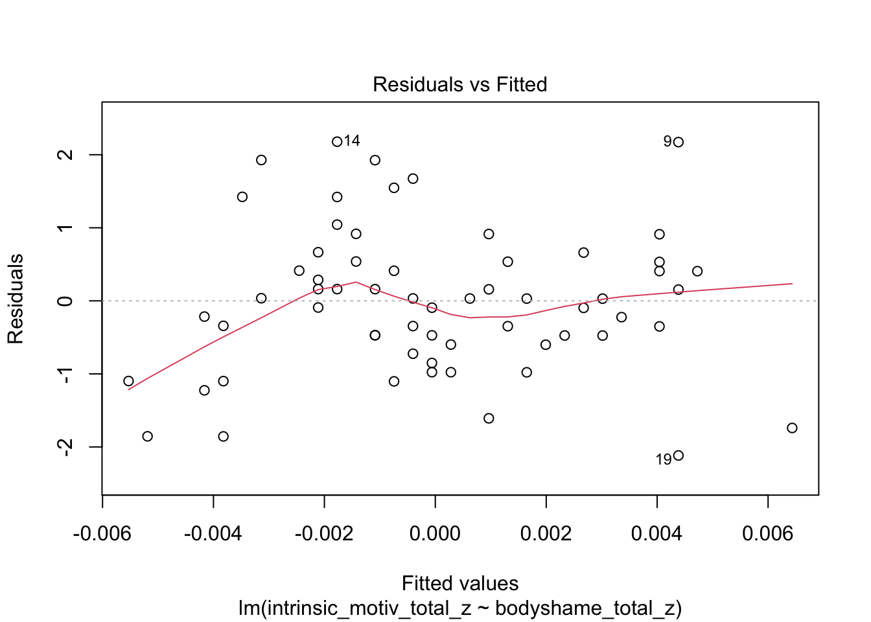*Residuals vs. fitted values for linear regression models predicting intrinsic (left) and extrinsic (right) exercise motivation.*

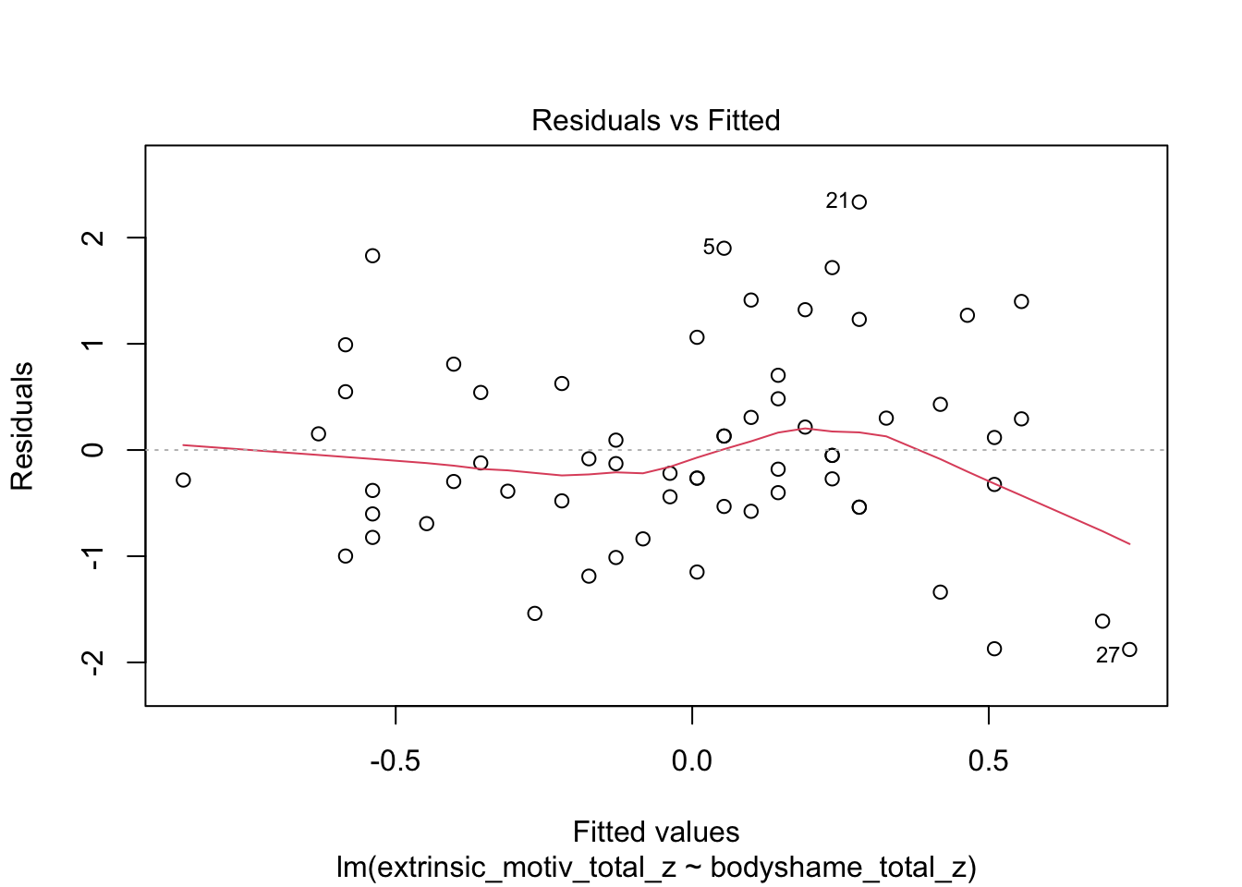

Plots visualize residual patterns for models predicting intrinsic and extrinsic motivation. The model for extrinsic motivation shows evidence of heteroscedasticity (p = 0.043, via ncvTest), reflected in a fan-shaped spread of residuals, indicating non-constant variance. In contrast, the model for intrinsic motivation shows no evidence of heteroscedasticity (p = 0.54), with residuals more evenly distributed. These patterns suggest that caution is warranted when interpreting standard errors in the extrinsic model.

**Figure F2.**

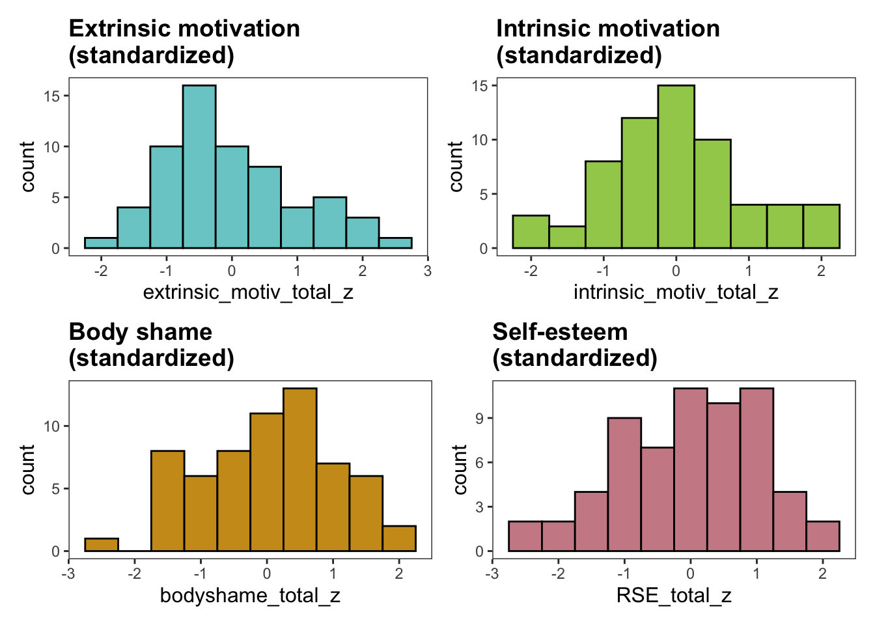*Histograms and Density Plots for Key Variables.*

Visual inspection and Shapiro-Wilk tests revealed no significant deviations from normality for intrinsic motivation, extrinsic motivation, body shame, or self-esteem, supporting the assumption of normality for linear regression.

***Figure F3.***

*Q-Q Plots for Residuals of Regression Models.*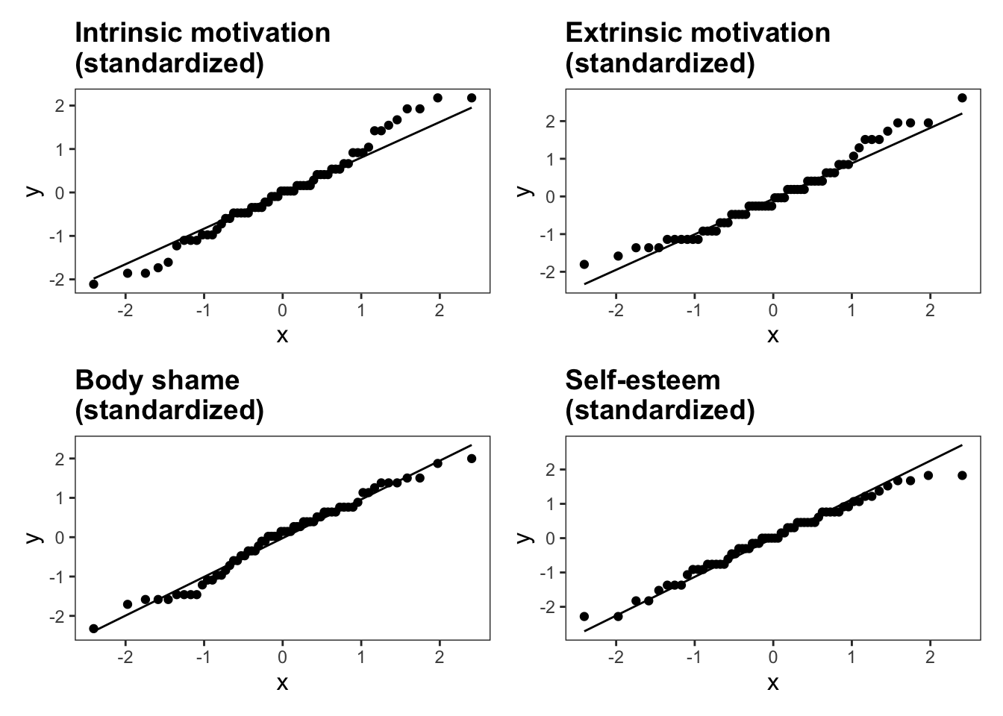

Residuals for models predicting intrinsic and extrinsic motivation follow a roughly normal distribution, with mild departure at the extremes. This suggests the assumption of normality of residuals is sufficiently met.

**Figure F4.**

*Scatterplots of Predictors vs. Motivation Outcomes.*

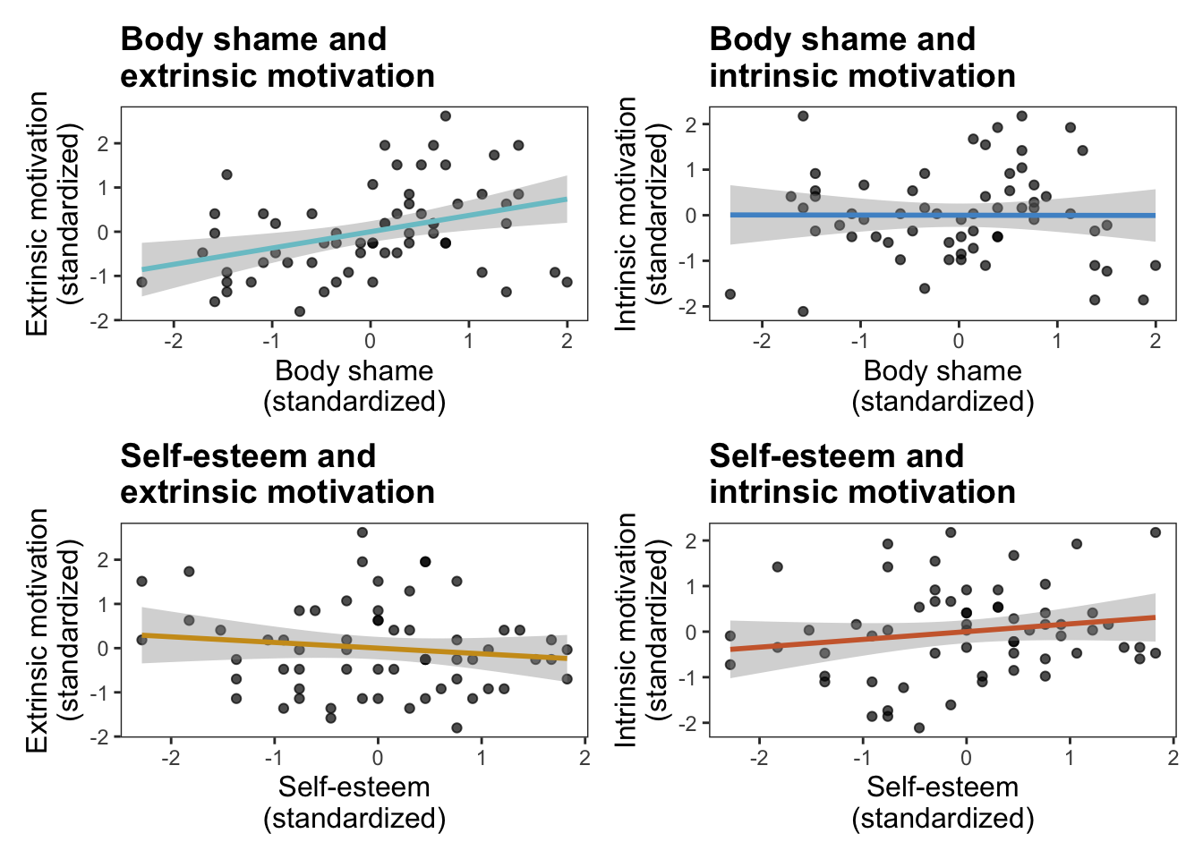

Plots of body shame and self-esteem against intrinsic and extrinsic motivation revealed no strong linear patterns, raising concerns about the linearity assumption in the regression models.

**Figure F5.**

*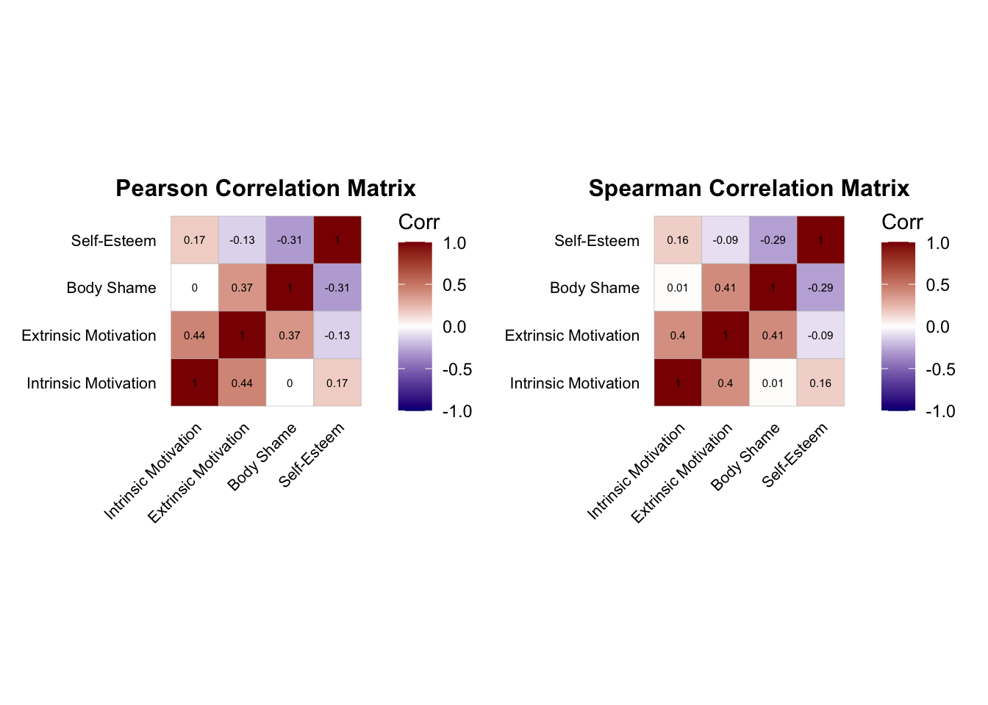Heatmaps of Pearson’s (left) and Spearman’s (right) correlation coefficients among exposure to overheard negative body talk, intrinsic motivation, extrinsic motivation, and self-esteem.*

Colors indicate the strength and direction of correlation, with darker shades representing stronger associations. Significant correlations (*p* < .05) are marked with asterisks.

**Figure F6.**

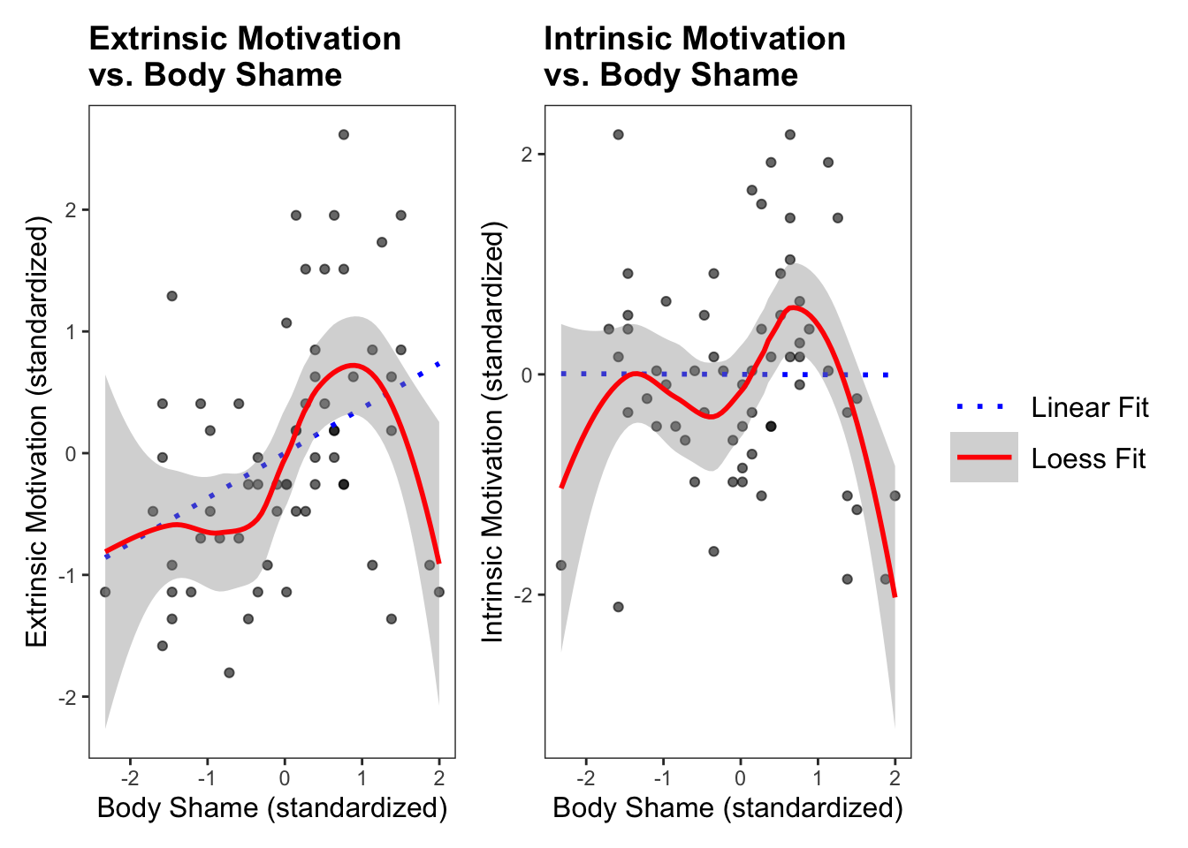*Linear and Loess Regression Lines for the Relationship Between Standardized Body Shame and Exercise Motivation*

This figure shows scatterplots of standardized body shame scores against intrinsic motivation (left) and extrinsic motivation (right) to exercise. Both linear regression lines (solid) and loess smoothing curves (dashed) are included to illustrate overall trends and potential nonlinear patterns. The positive linear trend for extrinsic motivation suggests higher body shame is associated with greater extrinsic motivation, while intrinsic motivation shows little to no relationship with body shame.

**Figure F7.**

*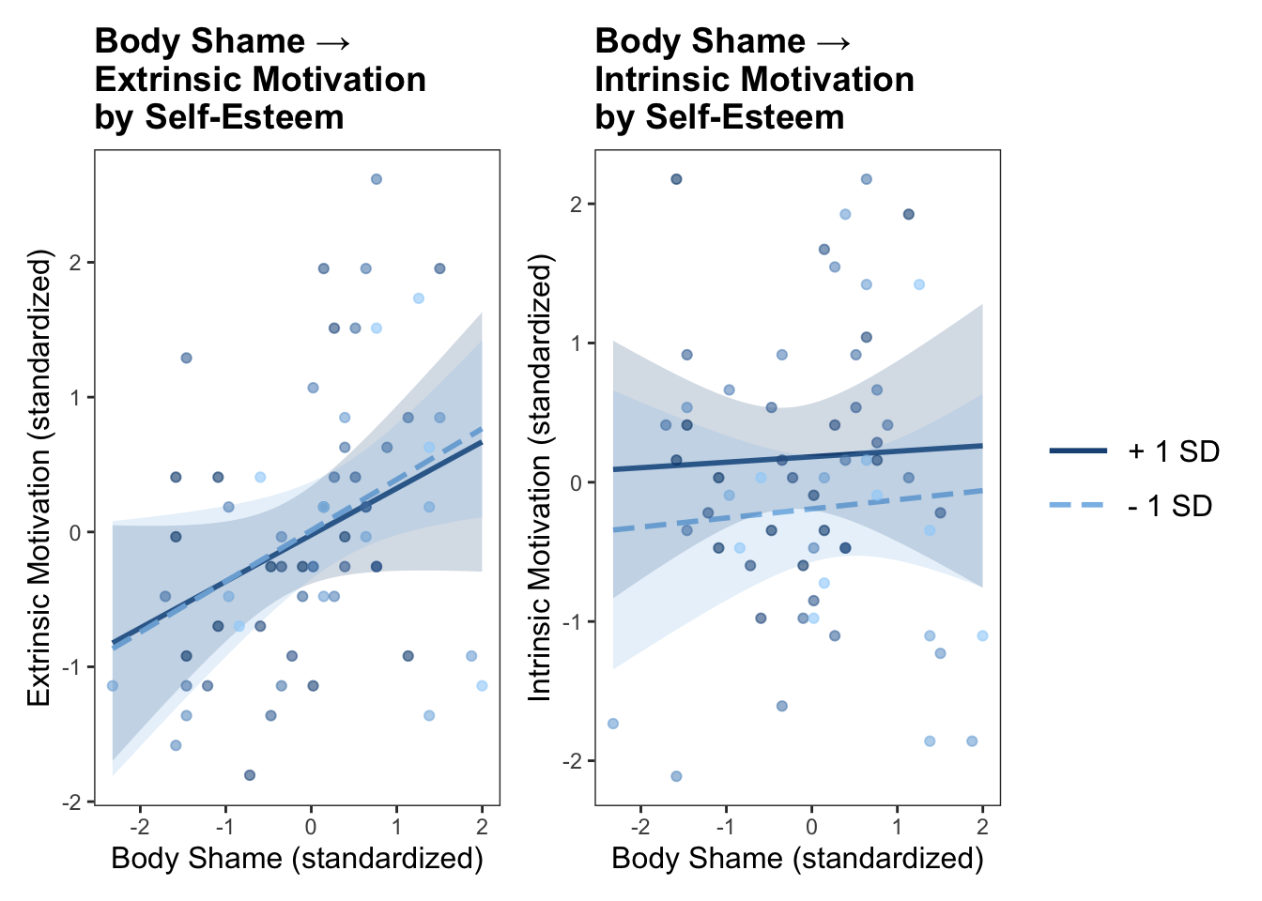Interaction of Body Shame and Self-Esteem on Extrinsic and Intrinsic Motivation to Exercise*

The figure displays predicted standardized extrinsic (left panel) and intrinsic (right panel) motivation scores as a function of standardized body shame at low (−1 SD), mean, and high (+1 SD) levels of self-esteem. Higher body shame is associated with greater extrinsic motivation across all levels of self-esteem, with no significant moderation effect. No significant relationships or moderation effects were observed for intrinsic motivation.